Prisoner’s Dilemma (4 Agents)
- Environment Description
The environment extends the classical two-player Prisoner’s Dilemma to a four-agent setting using the same pairwise payoff structure. Instead of a single two-player interaction, each episode involves every possible pair of the four agents playing the Prisoner’s Dilemma simultaneously. Payoffs are assigned pairwise and then summed and normalized so that reward magnitudes remain comparable to the two-agent case. Our code also produces CVS files, separate for each empathy level, which we import in Excel to graph the trends ourselves.

ACTION SPACE
Each agent chooses one of two actions per episode:
- C = Cooperate
- D = Defect

REWARD STRUCTURE (PAIRWISE PRISONER’S DILEMMA)
For each pair (i,j), the payoffs are:
(ai, aj) | Reward to i | Reward to j
(C, C) | 3 | 3
(C, D) | 0 | 5
(D, C) | 5 | 0
(D, D) | 1 | 1

In the 4-agent environment, each agent participates in three PD interactions (since it plays with each of the other three agents). The rewards received from each of these three pairwise games are added together and divided by 3. This keeps the reward scale identical to the original two-agent experiments.

STATE REPRESENTATION
Because the Prisoner’s Dilemma has no natural evolving state (each round is independent), the environment is technically stateless. However, Q-learning requires a state representation, so we provide a simple synthetic one: the joint action vector from the previous episode (e.g., (C, D, C, D)). This does not change the game itself, but it gives agents a minimal form of memory, allowing them to condition their behavior on what others did last round. This enables the emergence of reactive strategies and stabilizes learning in a multi-agent setting.

LEARNING SETUP
Each agent uses standard Q-learning with an ε-greedy exploration policy, where ε starts high (1.0) so agents initially explore random actions, and then decays by 0.995 per episode until reaching a minimum of 0.05. This gradually shifts behavior from exploration to exploitation as agents learn which actions yield higher value. The discount factor is γ = 0.95 and the learning rate is α = 0.2.

EMPATHY PARAMETER
As in the two-agent setup, we have the parameter α, which determines how much each agent values the rewards of others.
The shaped reward for agent i is:
$r_{i}^{shaped}=a_{emp}∙r_{i}+(1-a_{emp})∙\overline{r¬i}$
where $\overline{r¬i}$= average reward of the other 3 agents.

We evaluate four empathy levels:
- α_emp = 1.0 (fully selfish)
- α_emp = 0.8
- α_emp = 0.5
- α_emp = 0.2 (highly empathic)

2. Variable Description
The per-episode CSV files contain the following columns:
- episode: current trial
- alpha_emp: empathy level α used in this experiment
- A1_action, A2_action, A3_action, A4_action: Agent actions. Each entry ∈ {C, D}
- r1, r2, r3, r4: Selfish rewards. Each reward is the normalized sum of the three PD interactions that each agent participated in.
- r1_shaped, … r4_shaped: Empathy shaped rewards. Empathetic reward after modeling for empathetic behavior (thus valuing other agents’ rewards), using the empathy blending rule.
- epsilon_A1, epsilon_A2, epsilon_A3, epsilon_A4: Agent’s chance of exploring (instead of exploiting). Epsilon decays gradually per episode.
Cooperation tracking:
- coop_flag: Equals 1 only if all four agents choose C in that episode. Otherwise 0.
- moving_avg_coop: Rolling average of coop_flag across the last 100 episodes.
Welfare Tracking:
- total_reward: sum of all four selfish rewards
- moving_avg_total_reward: rolling average of total_reward across the last 100 episodes

The SUMMARY FILE for 4 agents reports the final 100-episode averages:
- last_100_avg_coop
- last_100_avg_total_reward
- time_to_coop_threshold (episodes until moving_avg_coop ≥ 0.8)

3. Results
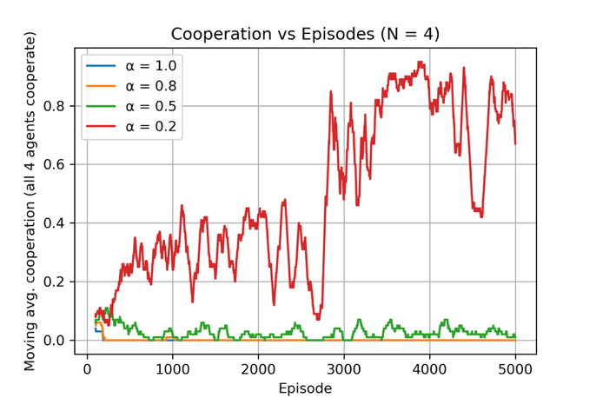
3.1 Cooperation Dynamics
The cooperation plot and data showa the moving average of episodes where all 4 agents simultaneously cooperated (C,C,C,C).
The curves show:
- α = 1.0 (selfish) → almost no cooperation
- α = 0.8 → also near zero cooperation
- α = 0.5 → low and unstable cooperation
- α = 0.2 → significantly higher cooperation, reaching ~80-90% in late episodes
INTERPRETATION
In the 4-agent Prisoner’s Dilemma, the difficulty of achieving cooperation is magnified. With four agents, full cooperation requires all four to choose C simultaneously. Any single agent defecting turns the entire episode into a non-cooperative one. This makes the cooperative equilibrium extremely fragile compared to the 2-agent case.
The results show:
- Selfish agents (α = 1.0)
- Explore early but quickly converge to the Nash equilibrium of mutual defection.
- Cooperation stays at or near zero.
- Weak empathy (α = 0.8)
- Not enough to break the incentive to defect.
- Agents still converge to defection as their stable strategy.
- Moderate empathy (α = 0.5)
- Encourages some cooperative episodes during exploration.
- But the environment is too unstable: one agent switching to D collapses cooperation for the whole group.
- So cooperation stabilizes at very low levels.
- Strong empathy (α = 0.2)
- Dramatically greater cooperation.
- Because 8shaped rewards reward group success, agents become aligned in choosing C together.
- However, fluctuations occur because with 4 agents, a single exploratory D move breaks the all-C pattern.

Conclusion: Empathy is again necessary to escape mutual defection, even more dramatically than in 2 agents. But the multi-agent nature makes convergence more volatile. Only strong empathy produces meaningful cooperation in 4-agent PD.

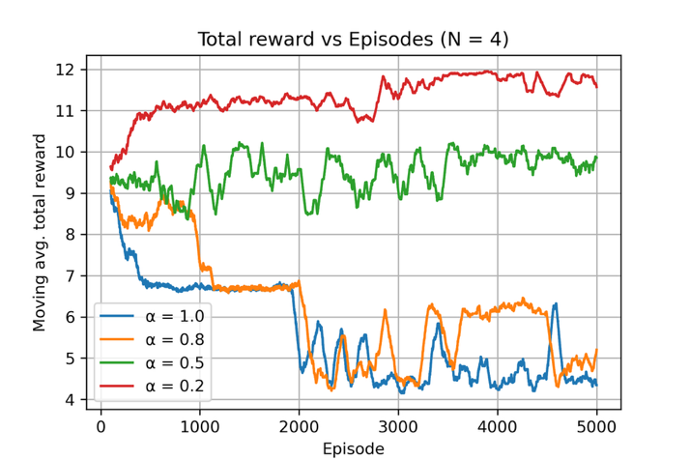
3.2 Total Reward Dynamics
The total reward plot shows:
- α = 1.0 → lowest total reward (~4-7)
- α = 0.8 → slightly higher but still low (~6-8)
- α = 0.5 → moderately better (~9-10)
- α = 0.2 → significantly highest (~11-12)

INTERPRETATION
Since full cooperation yields:
- Each agent = 3
- Total = 12
And full defection yields:
- Each agent = 1
- Total = 4

The graph shows:
- α = 1.0 stabilizes near the defection region.
- α = 0.8 performs similarly, meaning mild empathy is not enough to change the equilibrium.
- α = 0.5 floats around 9-10, meaning partial cooperation emerges occasionally.
- α = 0.2 hovers around 11-12, near the full-cooperation optimum.

This is strong confirmation that:
Empathy changes the effective incentives of the game, moving the agents from the low-welfare Nash equilibrium toward the high-welfare cooperative outcome. The fact that α = 0.2 stabilizes around a total reward of ≈12 shows that the agents have successfully learned to cooperate consistently (‘all-C, all the time’), even with ongoing exploration.
3.3 Why α = 0.2 works best
In a 4-agent setting:
- Mutual cooperation requires strong alignment
- Each agent must learn that “my reward depends on the group’s choices”
- The shaped reward for α = 0.2 heavily weights other agents’ success
- Therefore, it amplifies the cooperative signal and makes defection unattractive even if it yields a higher selfish reward in a single pairwise game

4. Final Interpretation (4-Agent PD)
- Cooperation in multi-agent PD becomes exponentially harder because the cooperative equilibrium requires all agents to independently commit to cooperation at the same time.
- Selfish RL agents fail completely: they converge to mutual defection (α = 1.0).
- Light empathy (α = 0.8) is still too weak to shift incentives.
- Moderate empathy (α = 0.5) creates temporary cooperation but cannot stabilize it.
- Strong empathy (α = 0.2) finally realigns payoffs enough to produce stable cooperative behavior.
- Total reward closely tracks cooperation levels: as agents become more empathetic, they collectively escape the low-welfare Nash equilibrium and approach the socially optimal cooperative outcome.
The 4-agent PD results therefore reinforce and deepen the core finding from the 2-agent experiments: Empathy directly changes what the agents learn to prioritize, and sufficiently strong empathy allows multi-agent systems to overcome competitive equilibria and converge to high-welfare cooperative behavior.

Resource Sharing (4 Agents)
1. Environment Description
In this environment, four Q-learning agents interact with a shared renewable resource instead of engaging in pairwise games. Each episode, all agents independently choose how much to extract from a common stock, which starts at 10 units and regenerates by 2 units per episode (capped at 10). This creates a collective-action problem: sustainable extraction benefits everyone, while over-extraction depletes the resource and harms the entire group.

ACTION SPACE
Each agent selects one extraction level per episode:
- 0 = low extraction
- 1 = medium extraction
- 2 = high extraction

REWARD STRUCTURE (common-pool resource game)
At each episode:
- If the total extraction ≤ current stock, each agent receives a selfish reward equal to the amount they extracted (sustainable use).
- If total extraction > stock, the resource collapses for that episode, and all agents receive a penalty of –0.5 (overuse).
After rewards are assigned, the stock is updated:
${stock}_{t+1}=max⁡(0, min⁡(10,{stock}_{t}-total extraction+2 ))$
Cooperation in this environment is defined as total extraction ≤ 4 (the empirically and mathematically sustainable threshold that avoids depletion under a regeneration rate of 2).

STATE REPRESENTATION
As in the Prisoner’s Dilemma, the environment has no natural evolving strategic state. However, Q-learning requires one, so each agent receives the previous stock level as the state. This gives agents minimal temporal context, enabling them to learn how their actions affect future resource availability.

LEARNING SETUP
The learning setup is identical to the Prisoner’s Dilemma section.

Empathy Parameter
Agents again use the shaped reward:
$r_{i}^{shaped}=a_{emp}∙r_{i}+(1-a_{emp})∙\overline{r¬i}$
Empathy levels tested are the same four.

2. Variable Description
The CSV files mirror the structure used in the 4-agent Prisoner’s Dilemma. Some additional notes are:
- total_extraction: sum of all four extraction actions
- stock_level: stock remaining after extraction and regeneration

3. Results
3.1 Cooperation Dynamics
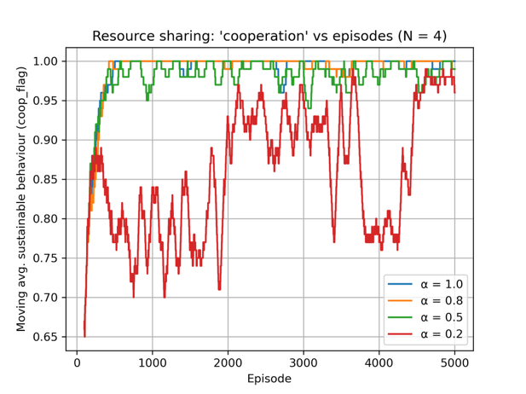
The cooperation plot shows the moving average of episodes in which total extraction stays within the sustainable threshold.
OBSERVED PATTERNS
- α = 1.0 (selfish): Cooperation quickly rises above 95% and remains near that value. Selfish agents eventually learn not to over-extract, because collapse penalties are immediate and costly.
- α = 0.8 and α = 0.5: These agents converge even faster to full sustainability and maintain almost perfect cooperation (≈100%) with very little variance.
- α = 0.2: Also converges to high cooperation, but the curve is more volatile, dipping periodically before recovering.
INTERPRETATION
Unlike in the Prisoner’s Dilemma, selfish behavior does not permanently trap agents in a low-welfare equilibrium. Because over-extraction immediately produces a negative reward for all, even selfish agents gradually learn that sustainable extraction is the best long-term strategy.
Empathy accelerates and stabilizes this process. Moderate empathy (α = 0.5–0.8) produces fast, smooth convergence to sustainable behavior. Very high empathy (α = 0.2) introduces instability because agents become overly sensitive to fluctuations in other agents’ rewards. Their shaped reward becomes noisy, slowing strategy consolidation.

Conclusion: In Resource Sharing, cooperation is easy to learn because the environment directly penalizes harmful behavior. Empathy does not determine whether agents cooperate (they all do), but rather how quickly and how stably they reach sustainable behavior.

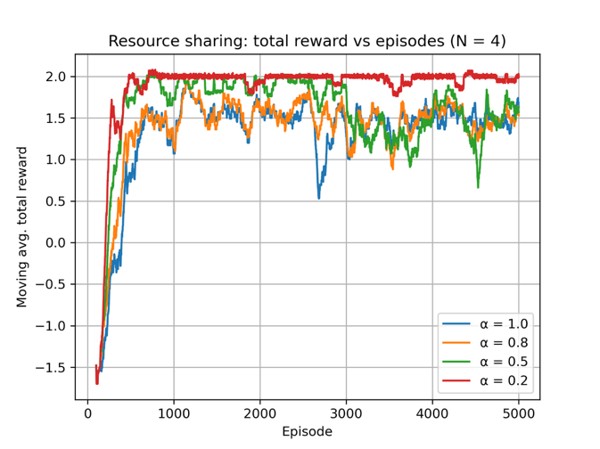
3.2 Total Reward Dynamics
The total reward plot tracks long-term collective welfare.
OBSERVED PATTERNS
- α = 1.0: Lowest total reward (~1.4–1.6), reflecting occasional over-extraction and instability.
- α = 0.8 and 0.5: Higher, stable total rewards (~1.6–1.8). These agents learn consistent sustainable extraction.
- α = 0.2: Highest long-term total reward (~2.0), approaching the maximum achievable given sustainability constraints.
However, the curve shows more variance, mirroring the fluctuations seen in cooperation.

INTERPRETATION
Empathy once again improves welfare by aligning individual incentives with group outcomes. When agents partially value others’ rewards, they avoid policies that deplete the resource and collectively settle into steady, sustainable extraction patterns. However, moderate empathy provides the most stable high-welfare behavior. Also, very high empathy yields the highest numerical welfare but at the cost of higher variance, because agents over-adjust to group behavior.

3.3 Why Moderate vs. Extreme Empathy Behave Differently
- Moderate empathy (α = 0.5–0.8)
  - Encourages coordination
  - Provides a clean learning signal
  - Avoids overreaction to noise
  - Produces stable sustainability
- Extreme empathy (α = 0.2)
  - Agents strongly weight others’ outcomes
  - Reward signal becomes noisy (non-stationary learning dynamics)
  - Causes oscillations, although the average performance remains highest

4. Final Interpretation (4-Agent Resource Sharing)
The Resource Sharing results contrast sharply with the Prisoner’s Dilemma. In PD, selfish agents never cooperate, and empathy is essential to escape mutual defection. In Resource Sharing, all agents eventually cooperate, because the environment naturally punishes overuse and rewards sustainability.
Empathy still improves outcomes, but in a different way; it enhances stability, accelerates convergence, and increases overall group welfare, even though cooperation emerges regardless.

Stag Hunt (4 Agents)
1. Environment Description
The Stag Hunt is a classic coordination game that captures situations where all players benefit most if they cooperate, but where cooperation only succeeds if everyone commits to it. In simple terms:
- Hunting Stag (S) gives the highest payoff, but only if all agents choose S together (corporation).
- Hunting Hare (H) is a safe, low-risk action that yields a smaller but guaranteed payoff, regardless of what others do (defection/ safety choice).
The core dilemma is whether to take the safe option (H), or risk choosing S in the hope that everyone else does too.
This makes Stag Hunt fundamentally different from the Prisoner’s Dilemma (in PD, defection always yields a higher selfish payoff - in Stag Hunt, cooperation (all choosing S) is actually the best outcome, but it requires trust and coordination).

IMPLEMENTATION
As in our Prisoner’s Dilemma experiments, we use the same MultiAgentMatrixGameEnv, where every possible pair of agents plays a Stag Hunt round simultaneously. Each agent chooses either H or S.
The pairwise payoff matrix is:
(ai, aj) | Reward to i | Reward to j
(S, S) | 4 | 4
(S, H) | 0 | 3
(H, S) | 3 | 0
(H, H) | 2 | 2

In the 4-agent version each agent interacts with all three others. Pairwise rewards are summed and normalized exactly as in the Prisoner’s Dilemma environment. This means the episode-level welfare reflects whether the group successfully coordinates on Stag (high payoff) or retreats to the safer Hare (low payoff) choice.

STATE REPRESENTATION
Stag Hunt, like PD, has no natural state evolution. Therefore, we use the same synthetic state representation: the joint action vector from the previous episode (e.g., (S, H, H, S)).
LEARNING SETUP
Identical to the other environments.
EMPATHY PARAMETER
Reward shaping is the same as before. Empathy levels tested are the same (1.0, 0.8, 0.5, 0.2).

2. Variable Description
Variables are identical to the ones from Prisoner’s Dilemma.

3. Results
3.1 Cooperation Dynamics
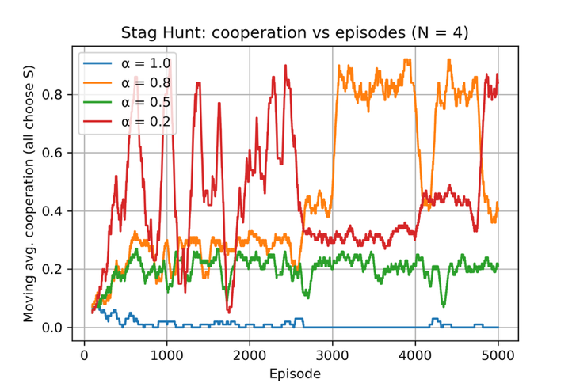
The cooperation plot shows the moving average of episodes where all four agents choose S (Stag). Unlike PD, the Stag Hunt theoretically has two equilibria:
- Safe but low-payoff: everyone chooses H
- Risky but high-payoff: everyone chooses S
Thus, the challenge is coordination, not avoiding exploitation.

OBSERVED PATTERNS
- α = 1.0 (selfish): Cooperation stays near zero throughout training. Agents consistently fall into the safe but inefficient “all H” equilibrium.
- α = 0.8 (moderate empathy): Cooperation rises slowly at first, then exhibits a dramatic jump around mid-training, stabilizing near 80–90% cooperation during the upper half of training. This is the highest and most stable cooperation among all empathy levels.
- α = 0.5 (strong empathy): Cooperation remains low (≈20–25%) and does not approach the fully cooperative S,S,S,S pattern. The agents frequently fail to coordinate, and episodes of full cooperation occur only sporadically.
- α = 0.2 (very strong empathy): Cooperation is volatile. It rises sharply in some intervals (up to ~80%), falls abruptly, and oscillates throughout training. Although cooperation sometimes reaches high values, it does not stabilize.

INTERPRETATION
These results show that in Stag Hunt, coordination and not incentives, is the bottleneck. Selfish agents (α = 1.0) prefer the safe Hare strategy; because they cannot rely on others choosing Stag, they converge to the risk-dominant equilibrium (all H). Moderate empathy (α = 0.8) changes this dynamic as agents become sensitive to group outcomes and learn that coordinated S choices lead to much higher rewards. Once a few agents begin playing S together, the system tips into the cooperative equilibrium and remains there. For α = 0.5 and α = 0.2, agents overweight others’ rewards, making their shaped reward signals unstable. Because the Stag Hunt is highly sensitive to group miscoordination (one H ruins the entire episode), this instability prevents stable convergence to full cooperation.

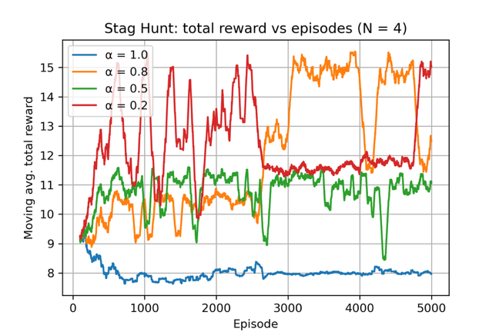
3.2 Total Reward Dynamics
The welfare plot reflects the same structure:
- Optimal welfare: (S,S,S,S) → each agent gets 4 → total = 16
- Safe equilibrium: (H,H,H,H) → each agent gets 2 → total = 8

OBSERVED PATTERNS
- α = 1.0: Stays around 8, matching the all-H equilibrium. Stable but inefficient.
- α = 0.8: Achieves the highest welfare, frequently approaching 15–16, indicating long stretches of full cooperation.
- α = 0.5: Welfare centers around 10–11, reflecting partial coordination—better than all-H but far from the cooperative optimum.
- α = 0.2: Peaks above 15 at times, but drops sharply and repeatedly. High potential payoff but poor stability.

INTERPRETATION
The results mirror the cooperation plot:
- Moderate empathy (α = 0.8) → best long-term welfare and most stable coordination
- Too little empathy (α = 1.0) → stuck in safe equilibrium
- Too much empathy (α = 0.2) → unstable rewards lead to unstable coordination
- Intermediate empathy (α = 0.5) → caught between both modes but unable to sustain the cooperative equilibrium

Because Stag Hunt is a coordination game with a fragile high-payoff equilibrium, the shaped reward must be strong enough to encourage joint cooperation but not so strong that it becomes noisy.

3.3 Why Empathy Levels Differ in Stag Hunt
The three environments in our project reveal that empathy does not behave uniformly across social dilemmas.
For Stag Hunt:
- Moderate empathy (0.8) provides the right signal strength, encouraging alignment without destabilizing learning.
- High empathy (0.2) causes overreaction to others’ momentary rewards, making policies unstable.
- Low empathy (1.0) keeps agents stuck in the “play it safe” equilibrium.
- 0.5 sits between these extremes and never fully commits to a stable cooperative strategy.
This produces a non-monotonic effect of empathy, unlike the Prisoner’s Dilemma where increasing empathy monotonically increased cooperation.

4. Final Interpretation (4-Agent Stag Hunt)
The 4-agent Stag Hunt results show a fundamentally different role for empathy compared to the Prisoner’s Dilemma and Resource Sharing. In PD, empathy is necessary to escape defection. In Resource Sharing, empathy improves stability and welfare but all agents eventually learn sustainability. In Stag Hunt, moderate empathy is optimal.
The high-payoff cooperative equilibrium (everyone choosing S) requires tight coordination. Empathy must be strong enough to encourage alignment, but not so strong that it amplifies noise in others’ behavior.
Thus:
- α = 0.8 achieves the best and most stable cooperative performance
- Too little empathy (1.0) → risk-dominant equilibrium (all H)
- Too much empathy (0.2) → unstable learning
- Moderate empathy (0.5) → inconsistent coordination

